Homeloan Choices Bulletin
Vol 122 – January

Fixed rate demand surges again

New data has found a growing proportion of borrowers are seeking the security that comes with a fixed rate home loan.

According to the latest national home loan approval data from Mortgage Choice, fixed rate home loans accounted for 22.04% of all loans written in December, up from 19.51% in the month prior.

“This is the fourth consecutive month that we have seen fixed rate demand increase,” Mortgage Choice chief executive officer John Flavell said.

“With speculation mounting that the Reserve Bank of Australia could soon lift the official cash rate, it is clear that a growing proportion of borrowers wish to beat any potential rate hikes by opting for a fixed rate home loan.”

Mr Flavell said current market conditions combined with a spate of rate increases by Australia’s lenders meant a rate rise by the Reserve Bank this year was now more likely than not.

“In December, the United States’ Central Bank announced it would increase the Federal Funds rate by 25 basis points to 0.75%. Furthermore, the bank indicated that the Federal Funds rate could rise by a further 75 basis points throughout 2017 – through three separate rate increases.

“Closer to home, many of Australia’s lenders have already started to raise rates across their suite of home loan products. In addition, the Reserve Bank of Australia has stated that the time for easing the monetary policy setting has now passed. All of these factors combined would suggest that a rate increase by the Reserve Bank could be right around the corner.

“Borrowers understand this and that is why a growing proportion of mortgage holders are opting for fixed rate products.”

Across the country, fixed rate demand was highest in New South Wales, with this type of product accounting for 27.34% of all loans written throughout the month of December.

“Queensland wasn’t far behind, with fixed rate home loans accounting for 24.64% of all loans written within the state. At the other end of the spectrum, fixed rate demand was lowest in Victoria, with this type of product making up just 12.69% of all home loans written,” he said.

“Looking ahead, I wouldn’t be surprised to see fixed rate demand continue to rise across most of the states as a growing proportion of borrowers look to beat the threat of rising rates.”

For archived copies of the Homeloan Choices bulletin, please refer to http://www.mortgagechoice.com.au/about-us/homeloan-choices-newsletter.

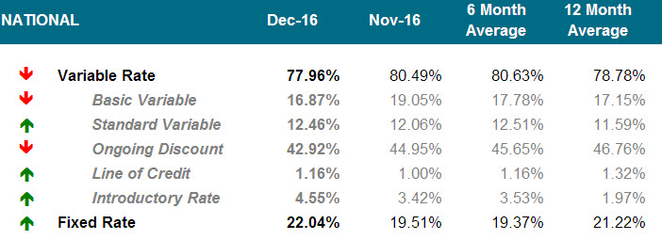

 | NSW/ACT |  | VIC/TAS |  | QLD |  | SA/NT |  | WA
Variable |  | 72.66% |  | 87.31% |  | 75.36% |  | 84.45% |  | 83.91%
Basic Variable | 9.76% |  | 16.04% |  | 25.14% |  | 33.53% |  | 15.66%
Standard Variable | 10.74% |  | 21.01% |  | 7.17% |  | 13.77% |  | 13.42%
Ongoing Discount | 46.96% |  | 43.43% |  | 36.61% |  | 32.59% |  | 51.52%
Line of Credit | 1.32% |  | 1.58% |  | 0.61% |  | 1.03% |  | 0.86%
Introductory Rate | 3.88% |  | 5.25% |  | 5.83% |  | 3.53% |  | 2.45%
Fixed |  | 27.34% |  | 12.69% |  | 24.64% |  | 15.55% |  | 16.09%

For further information, or to arrange an interview, please contact:

Jessica Darnbrough Brendan Wong
Mortgage Choice Corporate Affairs Mortgage Choice Corporate Affairs
(02) 8907 0472 / 0431 717 665 (02) 8907 0502 / 0414 299 282
jessica.darnbrough@mortgagechoice.com.au brendan.wong@mortgagechoice.com.au

Important information
This article is for general information purposes only. It has been prepared without considering your objectives, financial situation or needs. You should, before acting on the advice, consider its appropriateness to your circumstances.

About Mortgage Choice
Mortgage Choice is an ASX listed company that seeks to help Australians with all of their financial needs.
Established in 1992, Mortgage Choice was originally established to help Australians improve their financial situation by offering a choice of home loan providers, coupled with the expert advice of a mortgage professional.
Since that time, the company has grown and developed into a fully fledged financial services provider.
Today, Mortgage Choice helps customers source car loans, personal loans, credit cards, commercial loans, asset finance, deposit bonds, and risk and general insurance.
Further, the company offers Australians access to real, relevant and affordable financial advice through our qualified financial advisers.
Mortgage Choice has no balance sheet or funding risk, and consistently delivers strong profits and attractive yields. It listed on the ASX in 2004 (MOC) and is a member of the Mortgage & Finance Association of Australia (MFAA).
Mortgage Choice holds an Australian Credit Licence: no. 382869 and Mortgage Choice Financial Planning Pty Limited holds an Australian Financial Services Licence: no. 422854. Both licences are issued by ASIC.
Recent recognition: 2014 Australian Broking Awards Best Diversification Program; 2013, 2012, 2011 Australian Broking Awards Major Brokerage of the Year – Franchise; 2013, 2012 Australian Broking Awards Best Ethical/Social Responsibility Program; 2012 Australian Broking Awards Best Training and Education; No.1 on The Adviser magazine’s 2012, 2011, 2010 and 2009 Top 25 Brokerages list; 2012, 2010, 2009, 2008, 2006 and 2005 MFAA Awards Retail Aggregator/Originator of the Year; 2011, 2010, 2009 and 2008 10 Thousand FEET Top 10 Franchise list; 2010 Forbes Asia-Pacific Best Under A Billion list.
Visit www.mortgagechoice.com.au or call customer service on 13 6678.

