Homeloan Choices Bulletin
Vol 131 - October 2017

Fixed rate demand drops but remains high

Fixed rate demand dipped slightly over the month of September, according to new data.

The latest national home loan approval data from Mortgage Choice found fixed rate home loans accounted for 28.33% of all mortgages written throughout September, down from 31.05% in August.

“While we did see a slight dip in overall demand for fixed rate products last month, the proportion of borrowers looking to fix their mortgage is still significantly higher than we have seen historically,” Mortgage Choice chief executive officer John Flavell said.

“Traditionally, less than 25% of all borrowers chose to fix part or all of their home loan. In the last six months however, the average proportion of borrowers looking to fix their rate has jumped above 25% to 27.81%.

“From this data we can see that a growing proportion of borrowers are keenly searching for some surety and security when it comes to their regular mortgage repayments.”

Despite the fact that the Reserve Bank chose to leave the official cash rate on hold at 1.5% for the 14th consecutive month, Mr Flavell said future rate rises are now inevitable and borrowers are acutely aware of this fact.

“The cash rate is not going to remain at this level forever and it is inevitable that the Board will look to increase the current monetary policy setting at some point,” he said.

“When you combine the threat of potential rate increases with the fact that many of Australia’s lenders are currently offering some very sharp fixed rate products, it is only fair to assume that we will continue to see strong demand for fixed rate home loans.”

Across the country, Queensland had the highest level of fixed rate demand, with this type of product accounting for 29.01% of all loans written throughout September.

This was followed by Western Australia, where fixed rate loans accounted for 28.23% of all loans written, and Victoria, where fixed rate loans accounted for 28.08% of all loans written.

Overall, variable rates continue to be the most popular home loan product across Australia, with 71.67% of borrowers opting for this type of mortgage.

Regardless of the product that borrowers select, Mr Flavell said they would likely secure a very competitively priced product thanks to the historically low rate environment.

“Now is a great time to be a property buyer and/or a mortgage holder. Not only are interest rates continuing to hover around record lows, but lenders continue to aggressively compete for business through sharp home loan pricing,” he said.

For archived copies of the Homeloan Choices bulletin, please refer to http://www.mortgagechoice.com.au/about-us/homeloan-choices-newsletter.

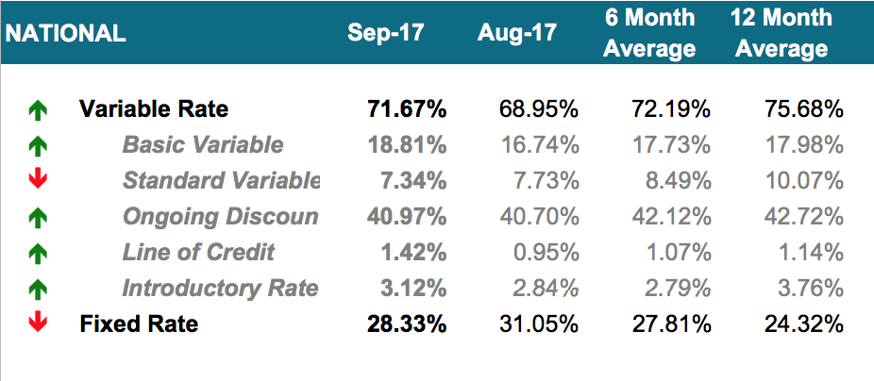

 | NSW/ACT |  | VIC |  | QLD |  | SA/NT |  | WA
Variable |  | 71.93% |  | 71.92% |  | 70.99% |  | 72.05% |  | 71.77%
Basic Variable | 21.22% |  | 16.27% |  | 19.03% |  | 9.60% |  | 23.44%
Standard Variable | 8.96% |  | 7.17% |  | 5.64% |  | 6.24% |  | 6.23%
Ongoing Discount | 37.67% |  | 43.46% |  | 41.79% |  | 52.35% |  | 34.54%
Line of Credit | 1.24% |  | 0.53% |  | 1.64% |  | 2.08% |  | 4.69%
Introductory Rate | 2.84% |  | 4.49% |  | 2.89% |  | 1.78% |  | 2.87%
Fixed |  | 28.07% |  | 28.08% |  | 29.01% |  | 27.95% |  | 28.23%

For further information or to arrange an interview with John Flavell, please contact:

Jessica Darnbrough Brendan Wong
Mortgage Choice Corporate Affairs Mortgage Choice Corporate Affairs
(02) 8907 0472 / 0431 717 665 (02) 8907 0502 / 0414 299 282
Jessica.darnbrough@mortgagechoice.com.au brendan.wong@mortgagechoice.com.au

Important information
This article is for general information purposes only. It has been prepared without considering your objectives, financial situation or needs. You should, before acting on the advice, consider its appropriateness to your circumstances.

About Mortgage Choice
Mortgage Choice is an ASX listed company that seeks to help Australians with all of their financial needs.
Established in 1992, Mortgage Choice was originally established to help Australians improve their financial situation by offering a choice of home loan providers, coupled with the expert advice of a mortgage professional.
Since that time, the company has grown and developed into a fully fledged financial services provider.
Today, Mortgage Choice helps customers source car loans, personal loans, credit cards, commercial loans, asset finance, deposit bonds, and risk and general insurance.
Further, the company offers Australians access to real, relevant and affordable financial advice through our qualified financial advisers.
Mortgage Choice has no balance sheet or funding risk, and consistently delivers strong profits and attractive yields. It listed on the ASX in 2004 (MOC) and is a member of the Mortgage & Finance Association of Australia (MFAA).
Mortgage Choice holds an Australian Credit Licence: no. 382869 and Mortgage Choice Financial Planning Pty Limited holds an Australian Financial Services Licence: no. 422854. Both licences are issued by ASIC.
Visit www.mortgagechoice.com.au or call customer service on 13 6678.

